**PRACTICAL 4**

**DHCP(Dynamic Host Configuration Protocol) and DNS()**

**Aim –** Create a network with a DHCP and DNS server.

**Theory –**

**Dynamic Host Configuration Protocol(DHCP)** is an application layer protocol which is used to provide:

1. Subnet Mask (Option 1 – e.g., 255.255.255.0)
2. Router Address (Option 3 – e.g., 192.168.1.1)
3. DNS Address (Option 6 – e.g., 8.8.8.8)
4. Vendor Class Identifier (Option 43 – e.g., ‘unifi’ = 192.168.1.9 ##where unifi = controller)

DHCP is based on a client-server model and based on discovery, offer, request, and ACK.

*DHCP Server:*

A**DHCP Server** is a network server that automatically provides and assigns IP addresses, default gateways and other network parameters to client devices. It relies on the standard protocol known as Dynamic Host Configuration Protocol or DHCP to respond to broadcast queries by clients.

A DHCP server automatically sends the required network parameters for clients to properly communicate on the network. Without it, the network administrator has to manually set up every client that joins the network, which can be cumbersome, especially in large networks. DHCP servers usually assign each client with a unique dynamic IP address, which changes when the client’s lease for that IP address has expired.

*DNS :*

The Domain Name System (DNS) is the phonebook of the Internet. Humans access information online through domain names, like nytimes.com or espn.com. Web browsers interact through Internet Protocol (IP) addresses. DNS translates domain names to IP addresses so browsers can load Internet resources.

Each device connected to the Internet has a unique IP address which other machines use to find the device. DNS servers eliminate the need for humans to memorize IP addresses such as 192.168.1.1.

**Topology –**

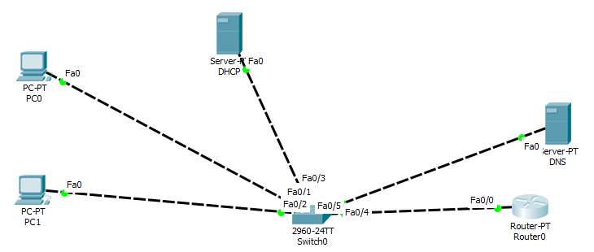

**Steps –**

*Step 1: Create Topology as shown above but do not assign the IP address to the PC.*

*Step 2: Start CLI for Router 1 and assign IP address for link connected to router.*

**Syntax for adding IP address:**

**int link_port**

**ip add [ip_address] [subnet_mask]**

**no sh**

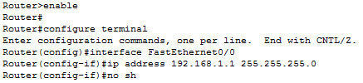

*Step 3: Now, go to DHCP server -> Desktop -> IP configuration*

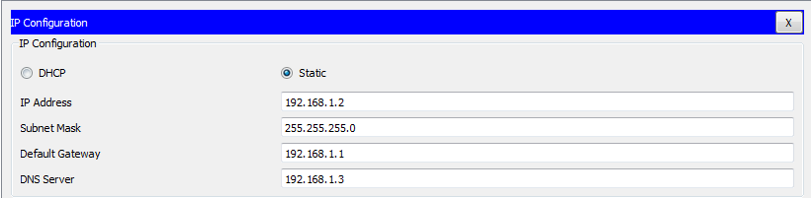

*Step 4: Now, In DHCP server go to services -> DHCP. Fill the fields like shown below and press save.*

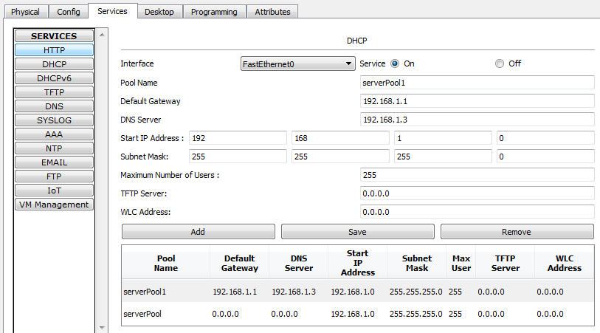

*Step 5: Now, go to DNS server -> Desktop -> IP configuration*

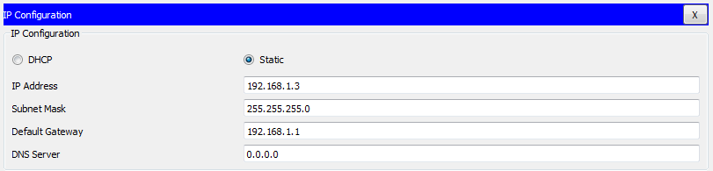

*Step 6: Now, In DNS server go to services -> DNS. Fill the fields like shown below and press add then save.*

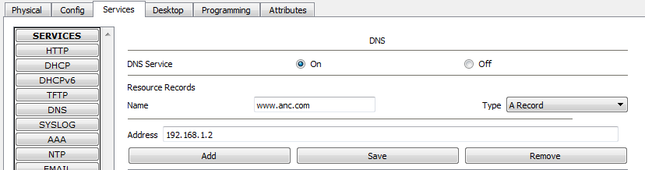

*Step 7: Now, Head back to DHCP server ->Services ->HTTP. Click edit in front of Index.html file and add a quick link www.anc.com over there. Save this file.*

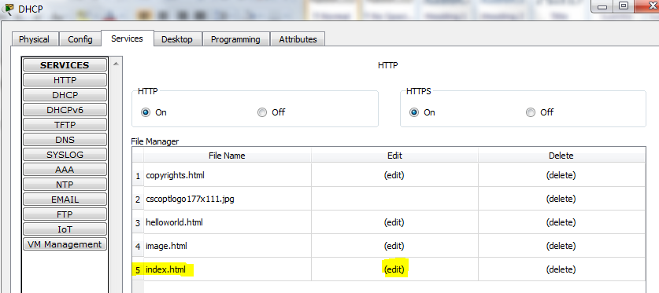

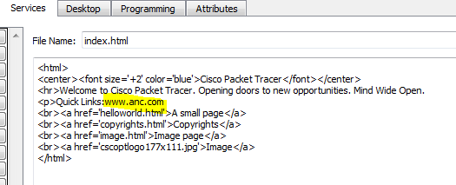

*Step 8: Now, go to the PC’s and request the IP address from server.*

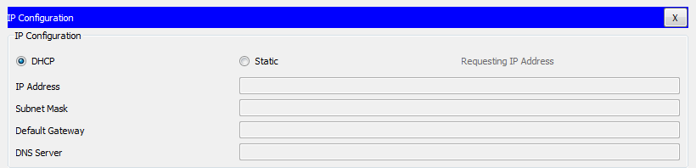

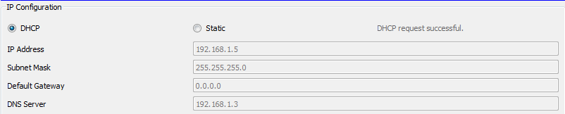

*Step 9: Now, go to a PC-> Desktop -> command prompt and ping the DNS website www.anc.com .*

